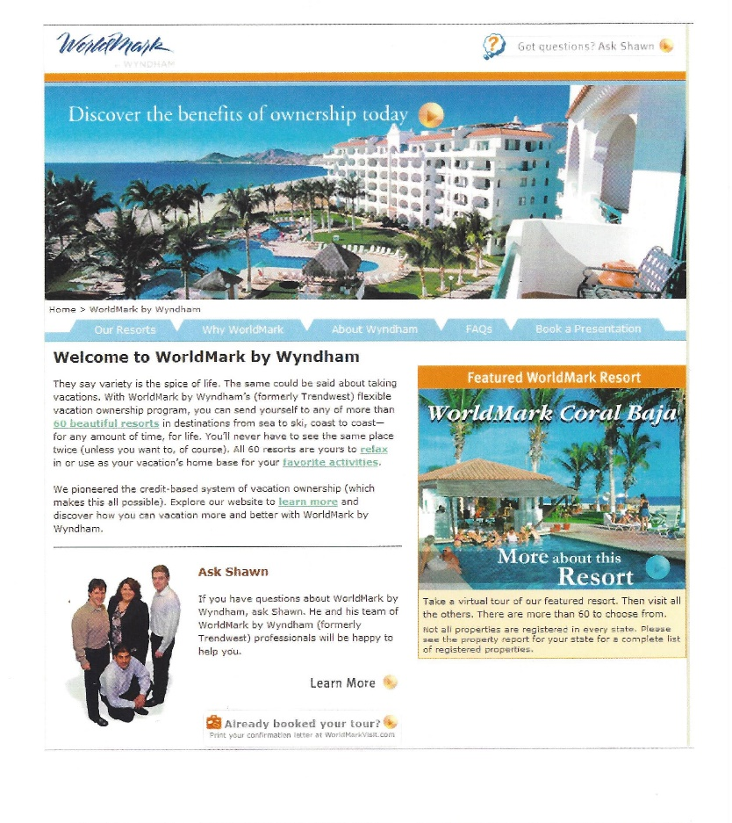 | The grit.  Whenever I approach a building a new website, I start with research. I want to know exactly what the customer wants to see and why. In this case the main complaint was they had been unable to find the information they need.  I have a philosophy I call “multiple points of access” and I applied that here. In the tabs, in links within the copy, the images themselves, all take you to pages or portals of information. I kept with the tried and true tabular presentation because my other overriding philosophy is “keep it simple and short.”
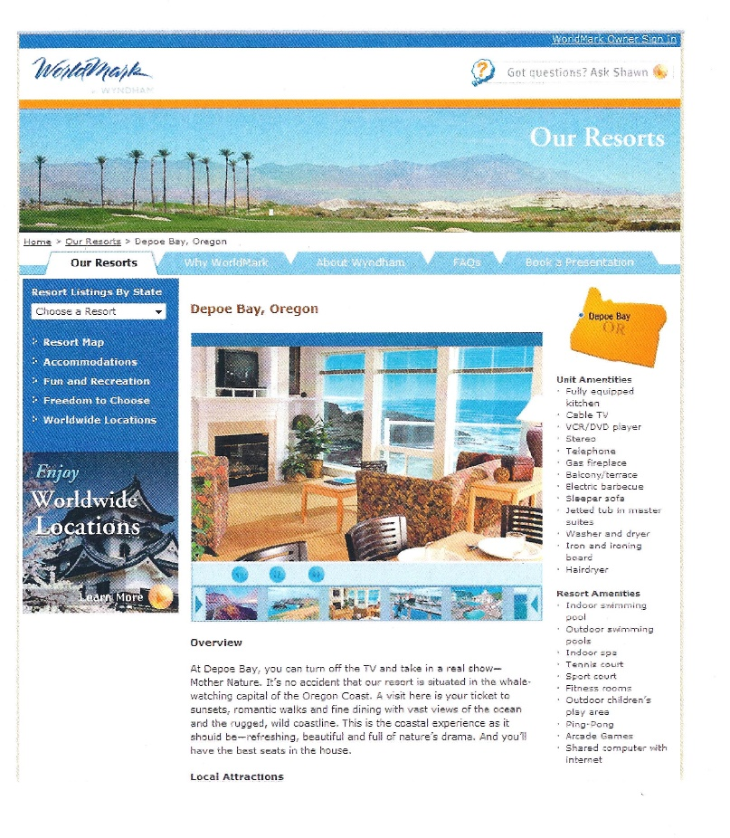 | This philosophy carried over to the core pages of the site—the resort destination pages. I found out from my customer research that they want to know where the resort is, what amenities it has, what there is to do around the resort, and so on. I wanted to give them all this information at a glance. This portion of the process took up perhaps the most time as the designer and I went through multiple iterations to get just the right balance.  But it worked. The eye goes to the big photo, where the customer can see there are other photos of the resort. Right next to it are the amenities—unit and resort. And finally, a very short romance copy description of the resort leading to a local attractions link.

